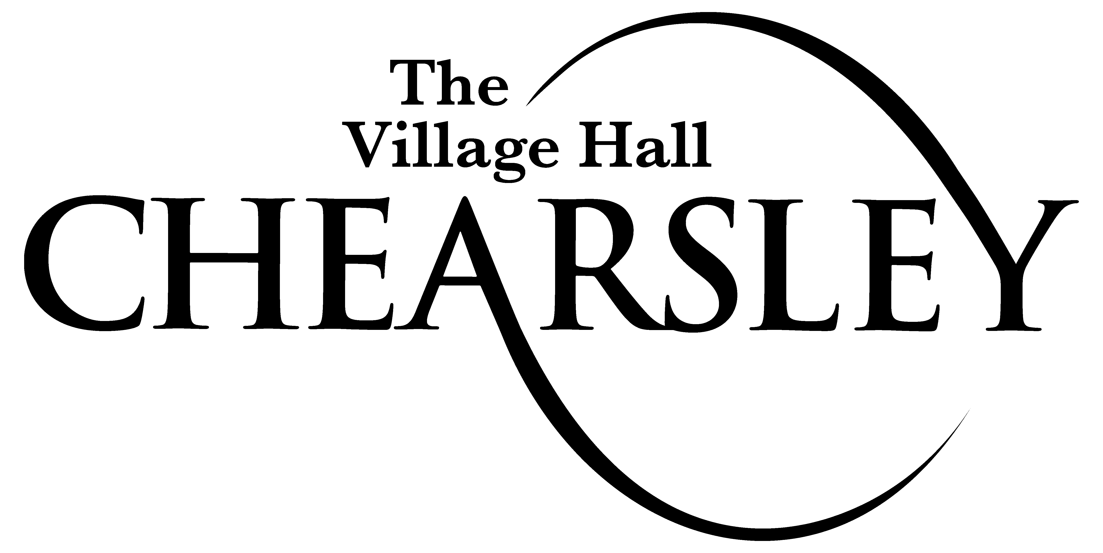

Last updated in November 2016

Introduction

Chearsley Village Hall Management Committee seeks to comply with all relevant Health and Safety legislation and to act positively where it can reasonably do so to prevent injury, ill health or any danger arising from its activities and operations.

Chearsley Village Hall Management Committee considers the promotion of the health and safety of those who use its premises, including contractors who may work there, to be of great importance. The Management Committee recognises that the effective prevention of accidents depends as much on a committed attitude of mind to safety as on the operation and maintenance of equipment and safe systems of work. To this end, the Committee will encourage its members, hirers, users and other visitors to engage in the establishment and observance of safe working and other practices.

Hirers, users and other visitors will be expected to recognise that there is a duty on them to comply with the practices set out by the Committee, with all safety requirements set out in the Hiring Agreement and with safety notices on the premises and to accept responsibility to do everything they can to prevent injury to themselves or others.

Responsibilities

Chearsley Village Hall Management Committee’s policy is:

- As far as is reasonably practicable, to eliminate accidents and minimise the likelihood of ill health being caused by working conditions.
- As far as is reasonably practicable, to ensure that the place of work is maintained in a safe condition, and that means of entry and exit are without risk.
- To provide and maintain a working environment for any employee, volunteer, and clients that is adequate with regards to facilities and arrangements for their welfare.
- To review the operation of the Policy and report to the Chearsley Village Hall Management Committee on its effectiveness.

The Chearsley Village Hall Management Committee have overall responsibility for health and safety at Chearsley Village Hall and takes day to day responsibility for the implementation of this policy to:

- Provide a safety service, including audit for the Hall, covering all aspects of safety and fire for Hall operations and other activities.
- Examine overall health and safety issues as they affect the Hall and ensure the development and introduction of improved assessment methods.
- Allocate sufficient resources to provide and maintain conditions and places of work that are, so far as reasonably practicable, safe and healthy.
- Take all reasonably practicable steps to ensure that premises in which work is carried out are operated and maintained so as to ensure, so far as is reasonably practicable, a safe and healthy system of working.
- Provide, where necessary, approved protective equipment and clothing and ensure that its proper use is understood.
- Take all reasonable steps to inform employees, subcontractors and clients about materials, equipment or processes used in their work which are known to be potentially hazardous to health or safety.
- Keep all operations and methods of work under review so that they can, if necessary, berevised in the light of experience and up to date knowledge.
- Promote joint consultation in health and safety matters to ensure effective participation by all Trustees, volunteers and users
- Provide appropriate facilities for first aid.
- Seek advice, where appropriate, when potentially hazardous situations exist or might
arise.
- Collect, analyse and promulgate data on accident, sickness and incidents involving
personal injury or injury to health and to investigate all such occurrences, and ensure
that recommendations are made to prevent recurrence.
- Seek to ensure that relevant and up-to-date information on all aspects of health and
safety legislation and good practice is obtained and made available to interested parties;

- carry out a continual assessment for any change of activity, process or equipment and
- make the findings of such an assessment generally available
- train new members as appropriate, volunteers and those taking on new jobs or
responsibilities and ensure that they are aware of any particular hazards of the job or working environment.

- Ensure that any accident is fully investigated and, where the fault lies with working methods, machinery, materials or processes, that such fault is corrected.

Hirers are responsible for:

- Reading the whole of the hiring agreement and must sign the hiring form as evidence that they agree to the hiring conditions. The hiring agreement states that all statutory or local regulations and rules for public safety must be strictly observed by hirers.
- Ensuring fire and safety equipment must not be misused or removed from its designated location.
- Ensuring fire and other exits must not be obstructed. Illuminated fire exit signs must be on for all public entertainment.
- Ensuring that adequate safeguards are in place to protect the well-being of the disabled, children and vulnerable adults.

Organisation of Health and Safety

- It is the duty of all hirers, users and other visitors to take care of themselves and others who may be affected by their activities and to co-operate with the Management Committee in keeping the premises safe and healthy.
- Should anyone using the hall come across a fault, damage or other situation which might cause injury and cannot be rectified immediately they should inform the Chairman or the Bookings Secretary, as soon as possible so that the problem can be dealt with.
- Where equipment is damaged or otherwise faulty a notice should be placed on it warning that it is not to be used and the Chairman or the Bookings Secretary informed as soon as possible.
- The following persons have responsibility for specific items:

First Aid box: Booking Secretary
Reporting of Accidents: Chairman
Fire precautions and checks: Chairman
Risk Assessment and Inspections: Chairman
Information to contractors: Chairman
Information to hirers: Booking Secretary
Insurance/ Licenses: Treasurer

Arrangements and Procedures

Insurance

- Chearsley Village Hall holds Employers Liability and Public Liability Insurance.
- Hirers of Chearsley Village Hall shall be responsible for making arrangements to insure against any third party claims which may lie against them (or the organisation if acting as a representative) whilst using the Premises.

Licences
- The sale of alcohol is prohibited but may be considered by the Chearsley Village Management Committee and with application for a Temporary Event Notice
from Aylesbury Vale District Council by the hirer.

Food Hygiene

- Hirers of the Hall should ensure they comply with relevant Food Hygiene legislation in relation to their activities.
- For advice regarding food hygiene in village halls the Food Standards Agency Document, Community and Charity Food Provision – Guidance on the Application of EU Food Hygiene Law, Dated 31st July 2013 –should be referred to.

Fire Precautions and Checks

- The Management Committee has completed a Fire Risk Assessment in accordance with the Regulatory Reform (Fire Safety) Order 2005.
- Person with responsibility for testing equipment and keeping log book: Treasurer
- Fire Safety equipment is regularly checked by a competent company as agreed by Chearsley Village hall management Committee.

Checking of Equipment, Fittings and Services

- Weekly: Door mats and stops, clock, toilets, water heater, stage, fridge, outside lights, emergency lighting, fire doors, all lights and torch.
- Monthly: First Aid Box, steps, locks and sockets.
- Half Yearly: Window cleaning, outside gutters,
- Yearly: Fire extinguishers, PAT testing, electrical certificate

Procedure in case of accidents

- The First Aid Box is located in the kitchen.
- Any accident must be reported to the Chairman of the Management
Committee.

Contractors

The Management Committee will check with contractors (including self-employed persons) before they start work that:

- The contract is clear and understood by both the contractors and the Chearsley Village Management Committee.
- The contractors are competent to carry out the work (e.g. have appropriate qualifications, references, experience).
- Contractors have adequate public liability insurance cover.
- Contractors do not work alone on ladders at height (if necessary a volunteer should be present).
- Contractors have their own health and safety policy for their staff.
- The contractor knows which member of the committee is responsible for overseeing that their work is as asked and to a satisfactory standard.
- Any alterations or additions to the electrical installations or equipment must conform to the current regulations.

